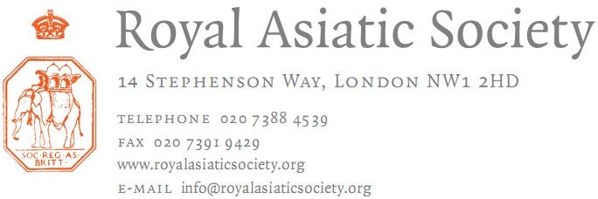

February 2021

Dear Fellow,

Election of Officers 2021

Every member of the Society is entitled under Standing Order 19 to nominate any Ordinary
Fellow of the Society to any vacant position on the Council of Management provided that he or she fulfils the
provisions of Byelaw 11. The relevant Byelaw is as follows:

Byelaw 11 provides that “An Ordinary Member of the Council who shall have had four years continuous service in that capacity shall retire with effect from the day of the Anniversary General Meeting, and shall not be eligible for re-election to the Council, except as President, Vice-President or Treasurer until at least one year shall have expired between their retirement and such re-election.”

A nomination to the Council must be signed by the sponsor and by a seconder and be accompanied by a statement signed by the nominee expressing willingness to serve if elected. The proposer
should supply a brief note (not more than half a page of A4) indicating key posts held, ways in which the candidate has participated in Society activities and/or would be of help to the Society’s operations.
Council members are expected to attend all five Council Meetings, the AGM and relevant committee meetings.

Please send any nominations to reach me by 21s
t March 2021.

Thank you.

Camilla W. Larsen
Executive Officer cl@royalasiaticsociety.org
0207 391 9420

The Royal Asiatic Society
of Great Britain and Ireland

The Council: 2020-2021

Professor A. J. STOCKWELL, President (2018-2021)
Dr B. BREND, Vice-President (2019-2022)
Mr L. KNIGHT, MBE Treasurer (2019-2022)
Dr S. ANSARI, Editor (2015-2021)

Dr P. COLLIN (2017-2021)
Dr R. G.S. COOPER (2017-2021)
Mr D. DAVIS (2019-2023)
Dr H.E. DRIVER (2020-2024)
Dr A. T. GALLOP (2020-2024)
Dr G. JOHNSON (2019-2023)
Dr F. MELVILLE (2018-2022)
Dr N. PEABODY (2019-2023)
Mrs E. ROBB (2019-2023)
Professor F. C. R. ROBINSON (2017-2021)
Mr I. SEDGWICK (2020-2024)
Dr J. SOKOLY (2018-2022)
Professor I. TALBOT (2017-2021)
Dr D. TAYLOR (2018-2022)
Dr S. WHITFIELD (2018-2022)
Dr M. WILLIS (2020-2024)

Professor A. J. Stockwell has completed three years as President.
Dr P. Collin, Dr R.G.S. Cooper, Prof. F. C. R. Robinson and Professor I. Talbot have completed four years of service as members of Council.
The post of student representative to Council has also become available. If you are interested in applying, please email the Director, Dr Alison Ohta on ao@royalasiaticsociety.org for more information.
NOMINATION FOR ELECTION OF THE COUNCIL OF THE ROYAL ASIATIC SOCIETY 2021

CANDIDATE DETAILS

NAME: ADDRESS:

TELEPHONE NO: E-MAIL:

DATE OF ELECTION AS FELLOW:
Please note that to be elected to Council, candidates must have been a Fellow of the RAS for one year (by the date of election)

BRIEF BIOGRAPHY: (to be attached on a separate sheet of paper)

I consent to being nominated for election to the Council of the Royal Asiatic Society

CANDIDATE’S SIGNATURE: DATE:

PROPOSER’S NAME:
PROPOSER’S SIGNATURE: DATE:

SECONDER’S NAME: SECONDER’S SIGNATURE: DATE:

